Danger Zone car game GDD

This is an idea for a survival/kind of text based adventure game I'm interested in making that emulates a sort of grind-house revenge story. You as the protagonist must track down a certain NPC in the environment. Wherever the NPC is depends on the day/time/how much info acquired... It’s a weird one to explain so let me show some stuff for it.

### MAIN SCREEN *(There will be animation)*

This is the main screen in which you see your car moving throughout the environment:

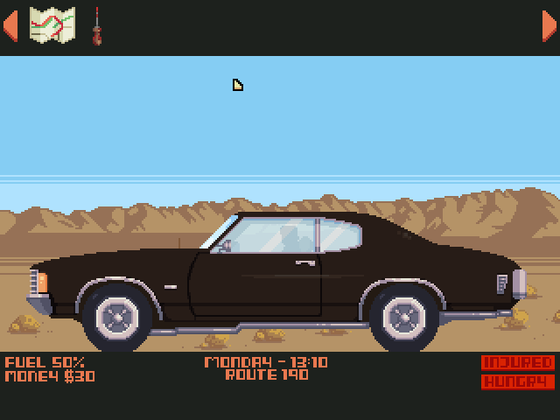

### Map Screen

When clicking on the map icon at the inventory (top) this screen appears, it shows the various locations in the environment. It starts out small but expands as you learn more information.

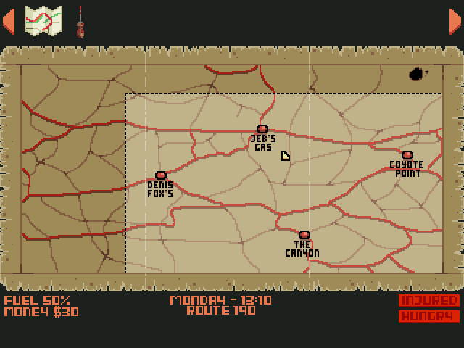

Let’s click on Jeb's Gas:

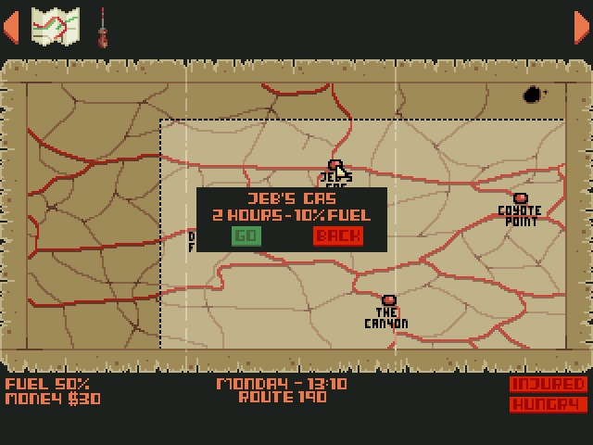

When clicking on an environment it will show you the time taken to get there and the fuel it will cost to make the Journey.

Let’s go there:

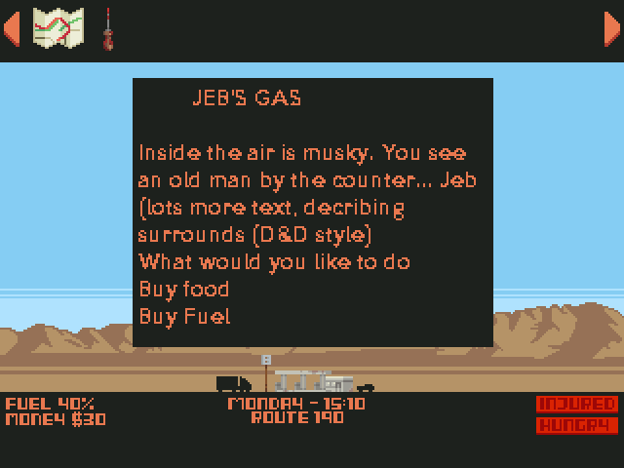

When visiting an environment you will be given a small view from outside and a text box. Inside the text box will be an area description (like *Shadowrun*) in the text box there will be character portraits to interact with, and you will be able to purchase resources too.

You have just under three days until the man you’re hunting meets his gang, making him essentially invulnerable.

You start with:

* $30
* A half tank of fuel (50% with each hour costing 5% fuel)
* An empty belly (hungry)
* A gunshot wound (wounded)
* 70 hours
* A map with three places marked on it:
  + Dennis Fox’s watering hole (4 hours from starting spot)
  + Jeb’s gas (3 hours from starting point)
  + Coyote Point (5 hours from starting point)

**Health** is measured from healthy -> wounded- > injured -> dead

**Hunger** is measured from full -> hungry - > starving -> dead

### Belt

Belt starts in the Canyon and drives around for 70 hours, taking rests along the way. In our test case, he will take the same route and actions on each play, being:

|  |  |  |  |  |  |
| --- | --- | --- | --- | --- | --- |
| hour | action | hour | action | hour | action |
| 1 | * Canyon | 25 | Drive | 49 | * Getsburg |
| 2 | * Canyon | 26 | * Doc Connors | 50 | Drive |
| 3 | * Canyon | 27 | Drive | 51 | Drive |
| 4 | Drive | 28 | Drive | 52 | Drive |
| 5 | Drive | 29 | Drive | 53 | Drive |
| 6 | Drive | 30 | Drive | 54 | Drive |
| 7 | Drive | 31 | * Molerat territory | 55 | Drive |
| 8 | Drive | 32 | Drive | 56 | * Radler Saloon |
| 9 | * Reevesvile | 33 | Drive | 57 | * Radler Saloon |
| 10 | * Reevesvile | 34 | Drive | 58 | Drive |
| 11 | Drive | 35 | Drive | 59 | Drive |
| 12 | Drive | 36 | * Oasis | 60 | Drive |
| 13 | Drive | 37 | * Oasis | 61 | Drive |
| 14 | * Rust | 38 | * Oasis | 62 | * Cemetery |
| 15 | Drive | 39 | * Oasis | 63 | Drive |
| 16 | Drive | 40 | * Oasis | 64 | Drive |
| 17 | Drive | 41 | * Oasis | 65 | Drive |
| 18 | Drive | 42 | Drive | 66 | * Gold mine |
| 19 | * Old Jenkin’s Ranch | 43 | Drive | 67 | Drive |
| 20 | Drive | 44 | Drive | 68 | Drive |
| 21 | Drive | 45 | Drive | 69 | Drive |
| 22 | Drive | 46 | Drive | 70 | * Ghost town |
| 23 | Drive | 47 | Drive |  |  |
| 24 | Drive | 48 | Drive |  |  |

### Locations

|  |  |  |  |  |  |  |  |
| --- | --- | --- | --- | --- | --- | --- | --- |
|  | Location name | Buy food | Buy gas | Rest here | quest | Buy info | Special |
| 1 | Dennis Fox’s |  |  |  | ✓ | ✓ |  |
| 2 | Jeb’s gas | ✓ | ✓ |  |  |  |  |
| 3 | Coyote point |  |  | ✓ |  |  | Take mountain pass:  - 50% risk of damage  - 50% chance to find Canyon |
| 4 | Canyon |  |  | ✓ |  |  | Find a note from Belt, saying Reevesville is his next destination |
| 5 | Reevesville | ✓ | ✓ |  |  | ✓ |  |
| 6 | Rust |  | ✓ |  | ✓ |  |  |
| 7 | The Old Jenkins Ranch | ✓ |  |  | ✓ |  |  |
| 8 | Doc Connors |  |  | ✓* |  | ✓ | *Heal – cure damage for x cash |
| 9 | Mole Rat territory |  | ✓ |  | ✓ |  |  |
| 10 | Oasis |  |  | ✓ |  |  |  |
| 11 | Getsburg | ✓ | ✓ |  |  |  |  |
| 12 | Radler Saloon | ✓ |  |  | ✓ | ✓ |  |
| 13 | Cemetery |  |  | ✓ |  |  |  |
| 14 | Goldmine |  | ✓ |  | ✓ |  |  |
| 15 | Ghosttown |  |  | ✓ | ✓ |  |  |

### Notes

* Belt’s path is not a straight line in one direction – the towns are scattered around, meaning the ghosttown *could* be near the canyon, or wherever we want. Otherwise Belt will just outrun you
* Quests each you cash and involve going to a place or bringing something from a place
* You spend an hour at each stop for refilling, talking, etc
* Each car has a radius of one hour, so you only need to get near Belt to catch him
* I think there should be a limited speed boost (either burn more fuel or use a nitro) that gives you a chance to make ground on Belt